# CS 255 System Design Document

*By Jacob Mueller*

*Upon the 16th of April, 2022*

*====================================================================================*

## UML Diagrams

### UML Use Case Diagram

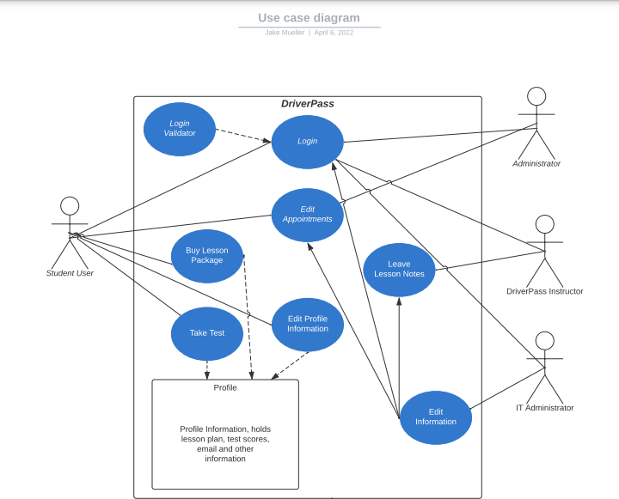

=====================================================================================

### UML Activity Diagrams

Activity Diagram of Student Customer actor editing their profile information:

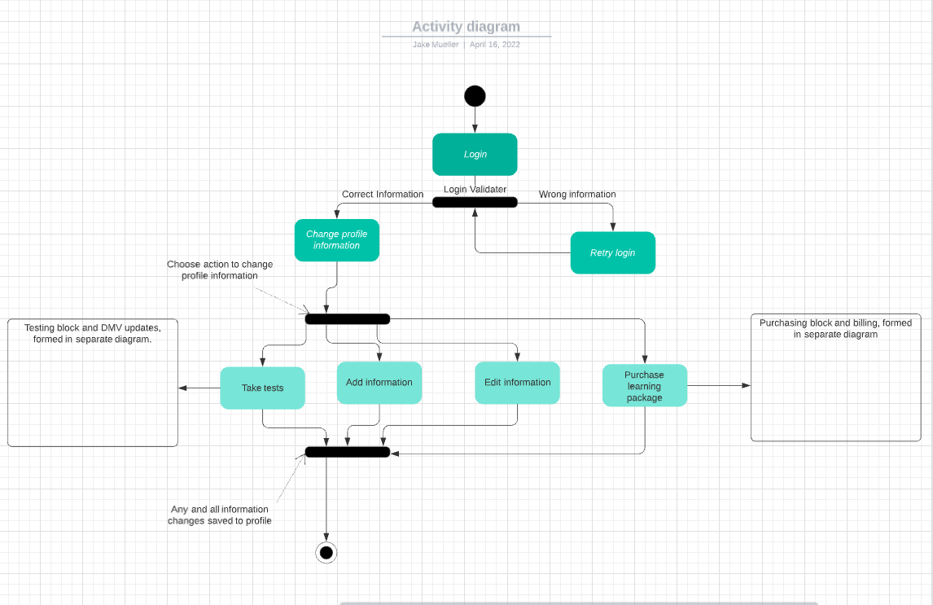

Activity Diagram for appointment administration:

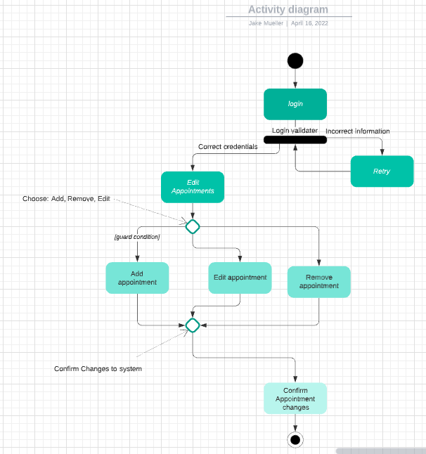

=====================================================================================

### UML Sequence Diagram

Sequence Diagram of Student Customer actor editing their profile information:

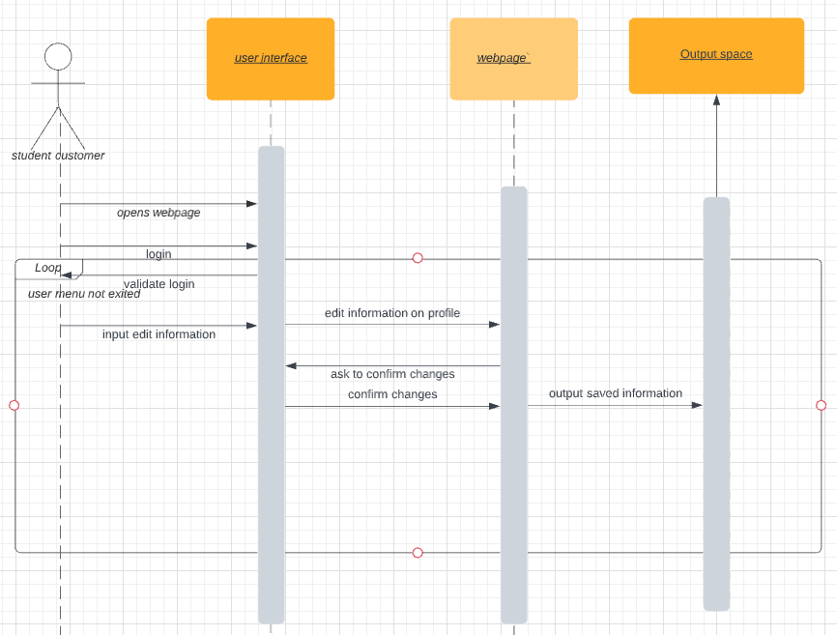

=====================================================================================

### UML Class Diagram

“DriverPass” Class Diagram

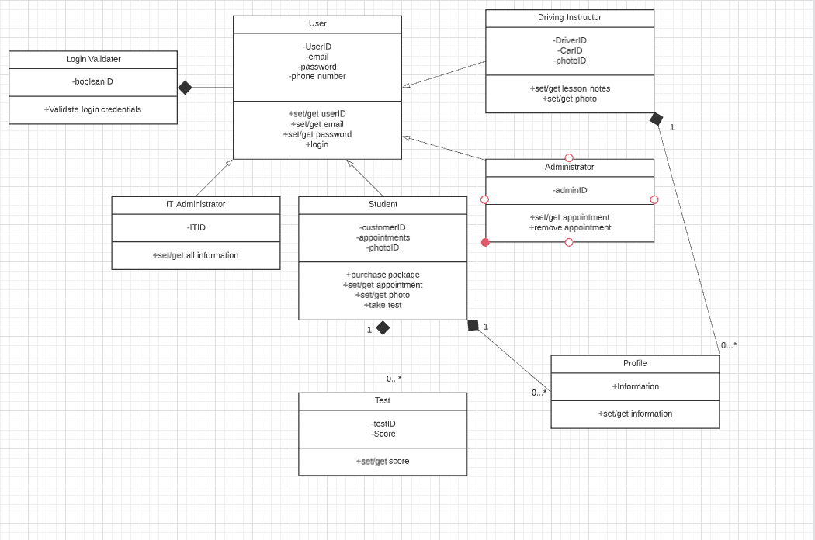

## Technical Requirements

The technical requirements demanded by the client for this system aren’t numerous, DriverPass is planning on using a cloud-based platform and understands that there are limitations on offline performance, despite that latter point being a preference in our planning stage. So, for hardware, as long as their [client] equipment is able to run whatever operating platform product they choose, there shouldn’t be a hardware issue or requirement on this project. Software on the other hand will need to be selected carefully to mitigate cross-platform issues, the administrative team and other backend users will primarily work on computers while the student-customers will operate on mobile devices, it’s just the way of the world. Our project software needs to be developed for both personal mobile devices and the office use hardware; apple products and developmental tools are great for handling the kind of cross-platform release DriverPass is going for. Given the on the road nature of the DriverPass instructors, and the proverbial lion’s share of the information being held by the administrative team, I think it will be best policy to have as much information stored on any user’s device as possible while deferring any unclaimed information and data onto the administrative team’s devices. Understandable there should be some extra storage purchased through the cloud-based platform’s distributor, but maybe there should be some personal hard drives for the administrators, so no data is lost in the event of a system failure.